# **ASSIGNMENT-3**

**FINANCIAL ANALYTICS**

TITLE: Analyzing competitive advantage between 2 real companies

Content

1. Introduction
2. Background
3. Competitive Advantage
4. Financial performance evaluation
5. Comparative Analysis
6. Assessment of sustainability
7. Conclusion

In this task I am analyzing the competitive advantage of two real companies of different industries. One company is from consumer goods sector i.e. **L’OREAL** and another company is from technology sector i.e. **SAMSUNG.**

* **INTRODU CTION**
* A Company from consumer goods sector : L’OREAL

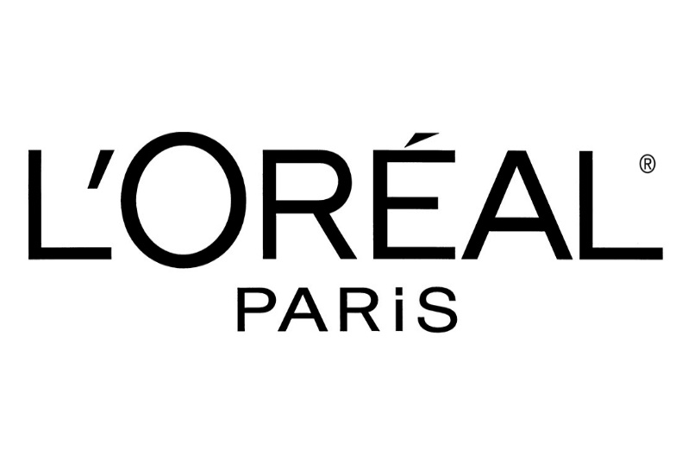

**L'Oréal S.A.** (French: [lɔʁe.al]) is a French [personal care](https://uci.edog.cdn.office.net/wiki/Personal_care) company headquartered in [Clichy](https://uci.edog.cdn.office.net/wiki/Clichy,_Hauts-de-Seine), [Hauts-de-Seine](https://uci.edog.cdn.office.net/wiki/Hauts-de-Seine), with a registered office in [Paris](https://uci.edog.cdn.office.net/wiki/Paris). It is the world's largest [cosmetics](https://uci.edog.cdn.office.net/wiki/Cosmetics) company and has developed activities in the field, concentrating on [hair color](https://uci.edog.cdn.office.net/wiki/Hair_coloring), [skin care](https://uci.edog.cdn.office.net/wiki/Cosmetics), [sun protection](https://uci.edog.cdn.office.net/wiki/Sunscreen), [make-up](https://uci.edog.cdn.office.net/wiki/Make-up), [perfume](https://uci.edog.cdn.office.net/wiki/Perfume), and [hair care](https://uci.edog.cdn.office.net/wiki/Hairstyling_product).

* A Company from technology sector : SAMSUNG

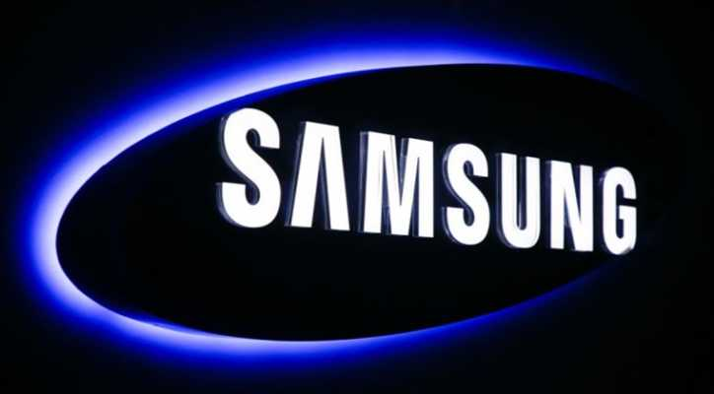

**SΛMSUNG** is a South Korean [multinational](https://uci.edog.cdn.office.net/wiki/Multinational_corporation) manufacturing [conglomerate](https://uci.edog.cdn.office.net/wiki/Conglomerate_(company)) headquartered in Samsung Digital City, [Suwon](https://uci.edog.cdn.office.net/wiki/Suwon), South Korea. It comprises numerous affiliated businesses, most of them united under the Samsung brand, and is the largest South Korean [*chaebol*](https://uci.edog.cdn.office.net/wiki/Chaebol) (business conglomerate). As of 2020, Samsung has the eighth-highest global [brand value](https://uci.edog.cdn.office.net/wiki/Brand_valuation).

Samsung was founded by [Lee Byung-chul](https://uci.edog.cdn.office.net/wiki/Lee_Byung-chul) in 1938 as a [trading company](https://uci.edog.cdn.office.net/wiki/Trading_company). Over the next three decades, the group diversified into areas including food processing, textiles, insurance, securities, and retail. Samsung entered the [electronics industry](https://uci.edog.cdn.office.net/wiki/Electronics_industry) in the late 1960s and the construction and shipbuilding industries in the mid-1970s; these areas would drive its subsequent growth.

* **BACKGROUND**

1. L’OREAL COMPANY :

**L’Oréal**, a global leader in the beauty industry, isn’t just about one iconic brand. You’d be surprised to learn about the vast portfolio of brands this powerhouse conglomerate owns. L’Oréal’s empire extends far beyond its namesake brand, owning a myriad of companies that span across various beauty sectors such as cosmetics, haircare, skincare and fragrance.

From luxury labels like **Lancôme** and **Yves Saint Laurent** to widely recognized drugstore staples like **Garnier** and **Maybelline New York**, L’Oréal’s reach is broader than you might initially think.

1. SAMSUNG COMPANY

Samsung is the world's largest manufacturer of [smartphones](https://uci.edog.cdn.office.net/wiki/Smartphone) since 2012. Samsung is best known for its [Samsung Galaxy](https://uci.edog.cdn.office.net/wiki/Samsung_Galaxy) brand including the [Samsung Galaxy S series](https://uci.edog.cdn.office.net/wiki/Samsung_Galaxy_S_series) which was first produced in 2010. It has developed [5G](https://uci.edog.cdn.office.net/wiki/5G)-capable smartphones, including the [Galaxy S24](https://uci.edog.cdn.office.net/wiki/Samsung_Galaxy_S24), and foldable phones, including the [Galaxy Z Fold 5](https://uci.edog.cdn.office.net/wiki/Samsung_Galaxy_Z_Fold_5). The company is a major vendor of [tablet computers](https://uci.edog.cdn.office.net/wiki/Tablet_computer), particularly its [Android](https://uci.edog.cdn.office.net/wiki/Android_(operating_system))-powered [Samsung Galaxy Tab](https://uci.edog.cdn.office.net/wiki/Samsung_Galaxy_Tab_series) collection, and is regarded for developing the [phablet](https://uci.edog.cdn.office.net/wiki/Phablet) market with the [Samsung Galaxy Note](https://uci.edog.cdn.office.net/wiki/Samsung_Galaxy_Note_series) family of devices. Samsung has also been the [world's largest television manufacturer](https://uci.edog.cdn.office.net/wiki/Television#Market_share) since 2006.

* **COMPETITIVE ADVANTAGES :**

|  |  |  |
| --- | --- | --- |
| **COMPANY NAME** | **L’OREAL** | **SAMSUNG** |
| **BRAND REPUTATION** | L'Oréal, the world's leading beauty company, has been recognized by the Ethisphere Institute, a global leader in defining and advancing the standards of ethical business practices, as one of the 2019 world’s most ethical companies. | Samsung Electronics today was recognized by Interbrand, a global brand consultancy, as a “GLOBAL TOP 5” brand for the fourth year in a row. |
| **PRODUCT DIFFERENTIATION** | The goal is to provide tailored, inclusive beauty solutions that meet specific, individual aspirations. L'Oréal's strategy in this regard is based on careful attention to consumers and a deep respect for their differing needs, lifestyles, desires and traditions. | Samsung’s generic competitive strategy and intensive growth strategies set business goals for technological innovation as a critical factor in developing competitive advantages. |
| **TECHNOLOGICAL INNOVATION** | L’Oréal is focused on inventing the future of beauty and becoming a Beauty Tech powerhouse. | Samsung first applied its AI-powered interface, Bixby, to the Galaxy S8 in 2017, and now users can control their major Galaxy devices using only their voice. In addition, Samsung has been incorporating AI technologies into its device OS, battery and camera in order to improve performance and convenience. |
| **MARKET LEADERSHIP** | In 2022, L'Oréal was the leading beauty manufacturer in the world, with revenues amounting to about 40 billion U.S. dollars. Globally employing more than 87,000 people in 2022, L'Oréal's global market share amounted to14 percent that year. | Market research firm Omdia reported that Samsung has achieved a 30.08% share of the global TV market in 2023, reinforcing its status as the industry leader since 2006. This success is largely due to the company's strategic focus on premium and large-screen TV categories, driven by its cutting-edge QLED and OLED models. |
| **DISTRIBUTION NETWORK** | Every year, L’OREAL Group distributes more than 6 billion products. It means that we are dispatching 2 orders every second, around the world, to 8 distinct types of distribution channels such as hair and beauty salons, mass market, e-commerce, travel retail. So, we are directly connected to the market – and to the expectations of consumers. | Samsung SDS develops strategies for the most efficient warehousing and transportation operations by using Cello and the latest IT solutions while shipping and storing your shipments safely and securely. They also maximize your operational efficiency by using a range of solutions to optimize and innovate warehouse tasks and processes. |

* **ANALYSING FINANCIAL PERFORMANCE:**
* **Analyzing financial performance of**

**L’ORAEL:**

1. **Revenue growth :** L'Oreal SA annual revenue for 2022 was $40.311B, a 5.53% increase from 2021. L'Oreal SA annual revenue for 2021 was $38.199B, a 19.47% increase from 2020. L'Oreal SA annual revenue for 2020 was $31.975B, a 4.43% decline from 2019.
2. **Profit margin ;**

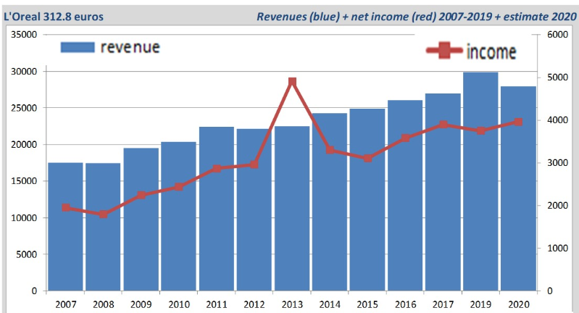

1. **Return on investment :**

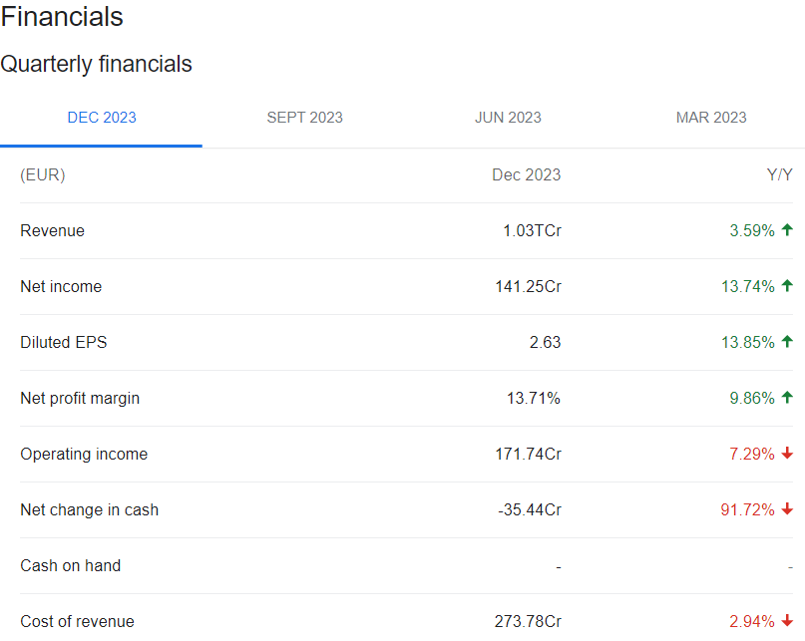

1. **Market share :**

In 2022, L'Oréal was the leading beauty manufacturer in the world, with revenues amounting to about 40 billion U.S. dollars. Globally employing more than 87,000 people in 2022, L'Oréal's global market share amounted to14 percent that year.

* **Analysing financial performance of**

**SAMSUNG :**

1. **Revenue Growth :** Samsung's consolidated revenue for 2023 was 258.94 trillion won ($193.98 billion approx.), down 14.32% YoY. Operating profit was 6.57 trillion won (around $4.92 billion.), down 84.85% YoY.
2. **Profit margin :**

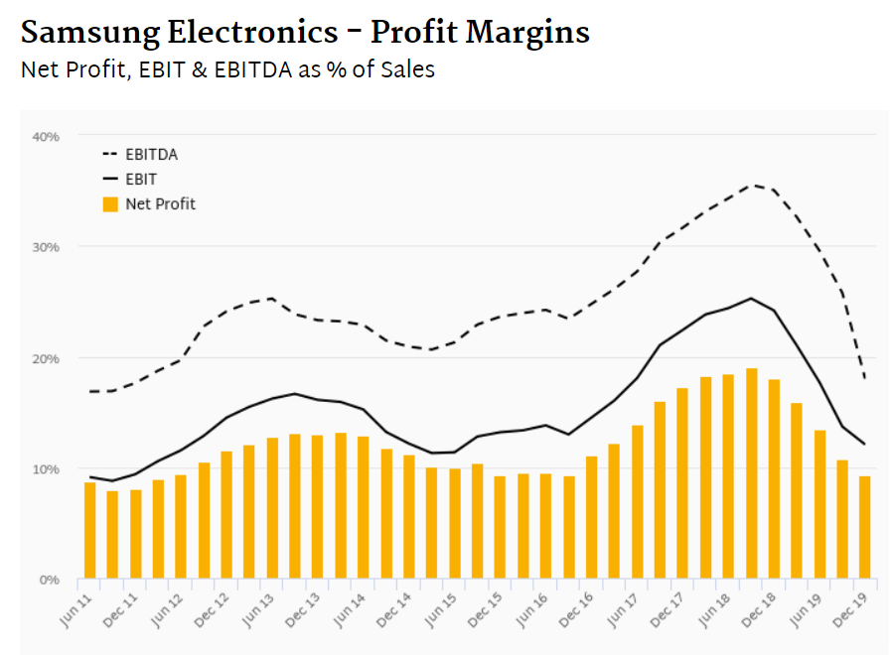

1. **Return on investment :**

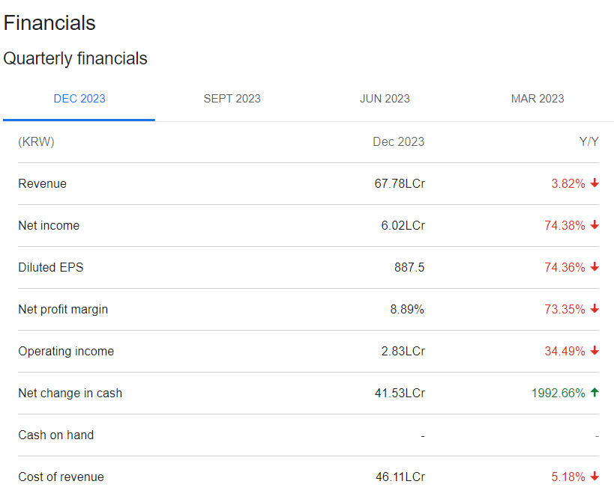

1. **Market share :**

Samsung has a market share of 24% in 2024. Samsung sales/shipments globally: Taking a 21% share of global shipments, 2 out of 10 phones shipped worldwide are Samsung phones. Approximately 258.20 million Samsung smartphone units were sold in 2022.

* **Compare competitive positions**

|  |  |  |
| --- | --- | --- |
| COMPANY NAME | L’OREAL | SAMSUNG |
| MARKET SHARE | In 2022, L'Oréal was the leading beauty manufacturer in the world, with revenues amounting to about 40 billion U.S. dollars. Globally employing more than 87,000 people in 2022, L'Oréal's global market share amounted to14 percent that year. | Samsung smartphone market share: Samsung has a market share of 24% in 2024. Samsung sales/shipments globally: Taking a 21% share of global shipments, 2 out of 10 phones shipped worldwide are Samsung phones. Approximately 258.20 million Samsung smartphone units were sold in 2022. |
| GROWTH PROSPECTS | L'Oreal India aims to become a 1-billion-euro business in the next 3-4 years, according to MD Aseem Kaushik. To achieve this target, the company plans to grow at double the pace of the Indian beauty market, which is estimated to grow at a rate of 9-10% CAGR. | Identifying the over 1B Samsung usersIn 2023 there were 1.03 billion active Samsung smartphone users - and that number is expected to grow in 2024. |
| COMPETITVE THREATS | Consumer preferences in the cosmetics industry can be highly unpredictable, and changes in trends or customer demands can quickly disrupt sales and revenue. | Samsung faces regulatory pressures in various markets regarding data privacy, antitrust, and environmental concerns. These regulations can lead to increased compliance costs, potential fines, and damage to the company's reputation. |
| BARRIERS TO ENTRY | The optimal barriers to enter the market includes product differentiation, government and legal requirements, capital requirements, economies of scale and others. | Building such a large brand is not easy. There is a lot of financial investment plus marketing and a need for highly skilled human resources. So, the barriers to entry are high. |

* **Assesment of Sustainability :**

Sustainability assessment requires an evaluation of present and future conditions to show that present decisions and actions are not compromising future human and ecological health and well-being.

1. **L’OREAL :**

Today L'Oréal Paris products are made in 26 factories around the world. Eleven of them are already carbon neutral (using 100% renewable energy, without offsetting) and the remaining ones will reach this goal in 2025.

By 2030, 95% of our ingredients in formula will be biobased, derived from abundant minerals or from circular processes. By 2030, 100% of the plastics used in L'Oréal's products' packaging will be either from recycled or bio-based sources (we will reach 50% in 2025).

1. **SAMSUNG :**

Samsung Electronics is committed to embedding sustainability in our business and product strategies while striving to play a leading role in the global effort to build a sustainable future. Growing environmental and socioeconomic risks coupled with geopolitical uncertainties have reinforced our belief that sustainability needs to be a key force for driving our competitiveness and technological innovation.

* **CONCLUSION :**

1. **L’OREAL:** L'Oreal produces a wide range of beauty products and because of the many different brands, it stands apart from companies who only have one product to sell. Furthermore, because L'Oreal is global it recognizes that beauty is not one-sided and incorporates products for people of different color and texture.
2. **SAMSUNG :** Samsung specializes in the production of a wide variety of consumer and industry electronics, including appliances, digital media devices, semiconductors, memory chips, and integrated systems. It has become one of the most-recognizable names in technology and produces about a fifth of South Korea's total exports.It is clear that the company is still a global leader in chip making and smartphone brands. It has always sustained sufficient revenue and profits as it progresses into the future.